1. On the Rhizopus diagram below, the structure labeled "a" is a
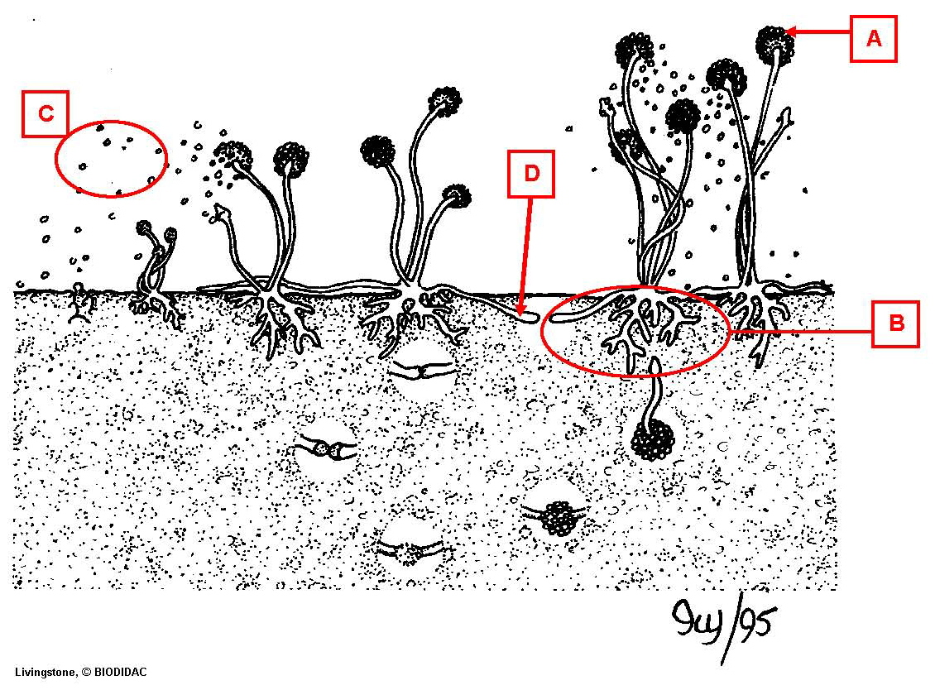

a. hypha
b. mycelium
*c. sporangium
d. spores

2. On the Rhizopus diagram below, the structure labeled "b" is the

a. hypha
*b. mycelium
c. sporangium
d. spores

3. On the Rhizopus diagram below, the structures labeled "c" are

a. hypha
b. mycelium
c. sporangium
*d. spores

4. On the Rhizopus diagram below, the structure labeled "d" is a

*a. hypha
b. mycelium
c. sporangium
d. spores

5. On the diagram of Rhizopus life cycle, the structure labeled "a" is
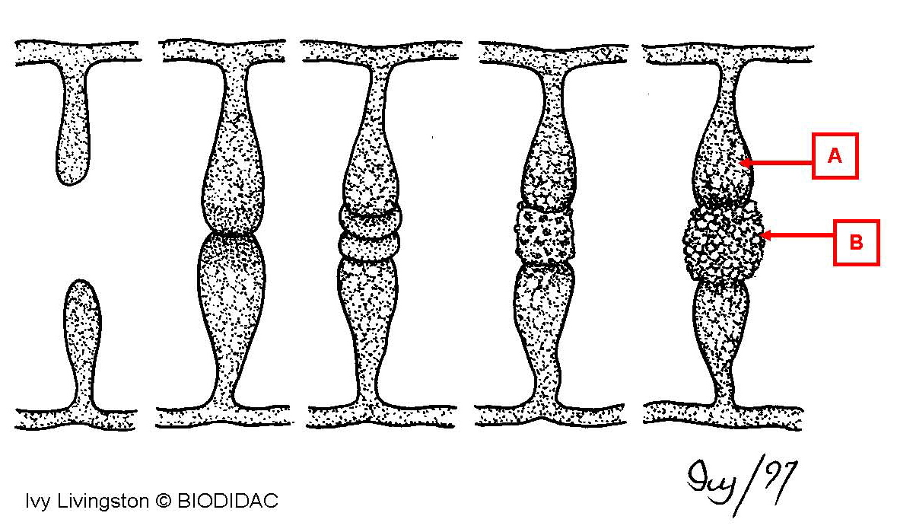

a. ascocarp
b. basidiocarp
c. sporangium
*d. suspensor cell
e. zygosporangium

6. On the diagram of Rhizopus life cycle, the structure labeled "b" is

a. ascocarp
b. basidiocarp
c. sporangium
d. suspensor cell
*e. zygosporangium

7. On the diagram of a mushroom, the structure labeled "a" is a
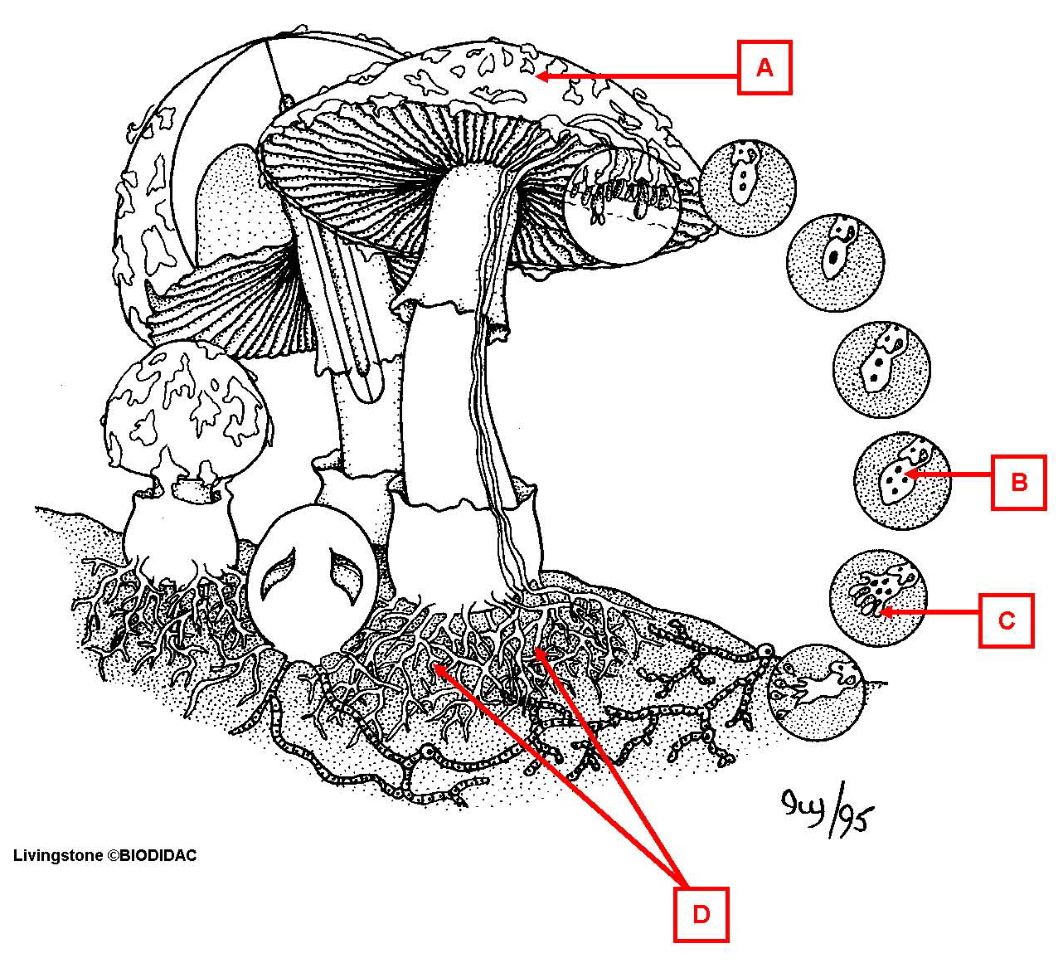

*a. basidiocarp
b. basidiospores
c. basidium
d. mycelium

8. On the diagram of a mushroom, the structure labeled "b" is a

a. basidiocarp
b. basidiospores
*c. basidium
d. mycelium

9. On the diagram of a mushroom, the structure labeled "c" is a

a. basidiocarp
*b. basidiospores
c. basidium
d. mycelium

10. On the diagram of a mushroom, the structure labeled "d" is a

a. basidiocarp
b. basidiospores
c. basidium
*d. mycelium

11. On the diagram of a cup fungus life cycle, the structure labeled "a" is a/an
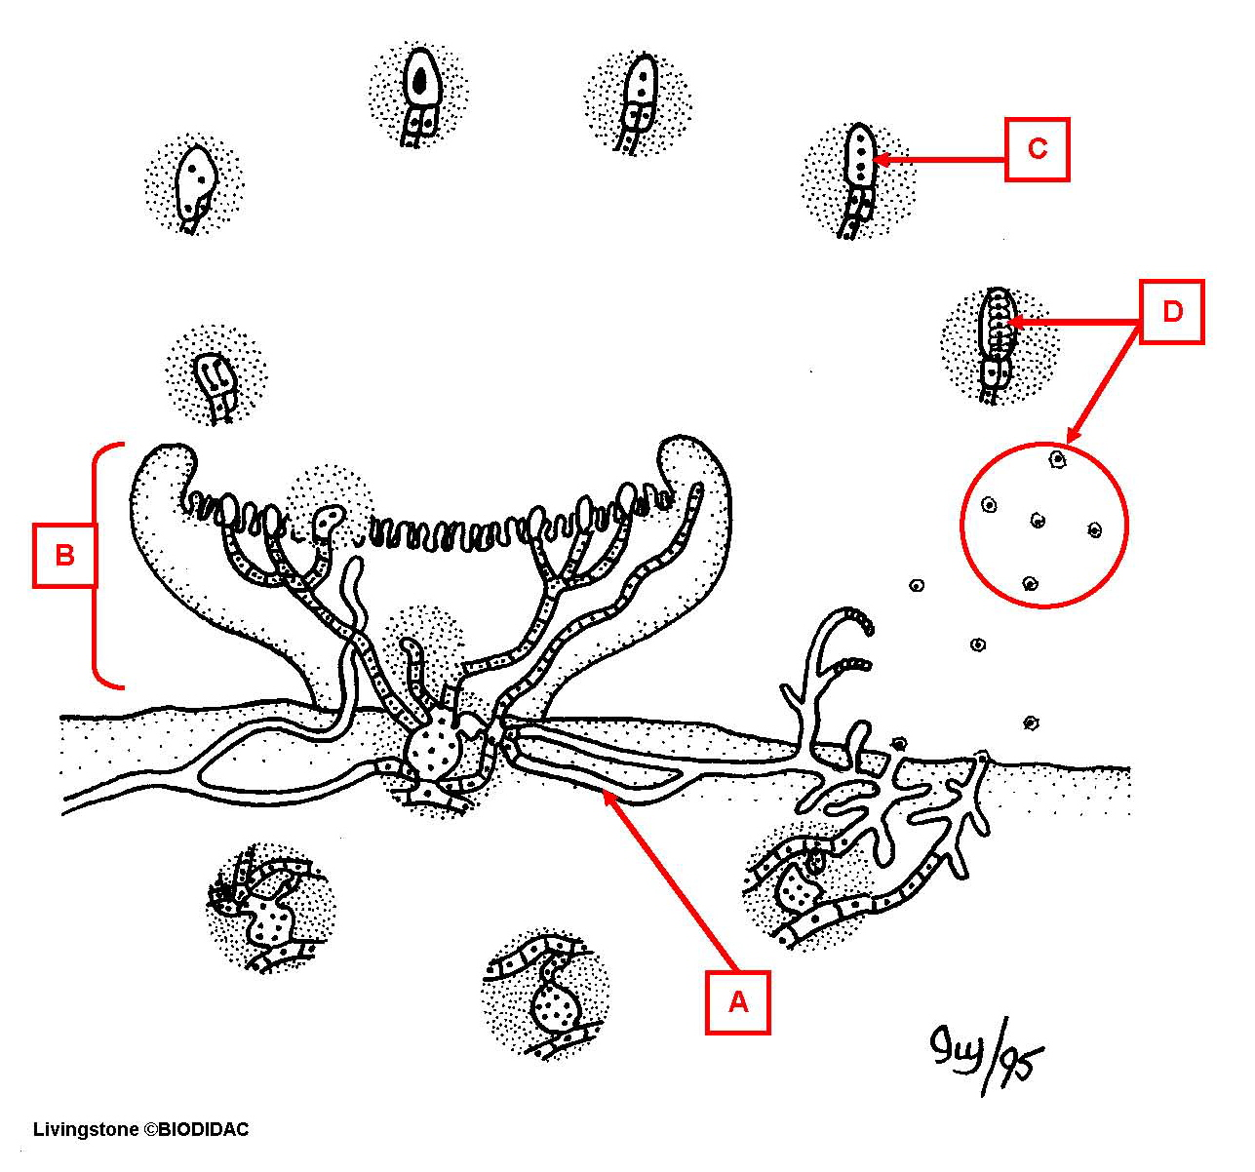

a. ascocarp
b. ascospores
c. ascus
*d. hypha

12. On the diagram of a cup fungus life cycle, the structure labeled "b" is a/an

*a. ascocarp
b. ascospores
c. ascus
d. hypha

13. On the diagram of a cup fungus life cycle, the structure labeled "c" is a/an

a. ascocarp
b. ascospores
*c. ascus
d. hypha

14. On the diagram of a cup fungus life cycle, the structures labeled "d" are

a. ascocarp
*b. ascospores
c. ascus
d. hypha

15. On the closeup diagram of a mushroom gill, the structure labeled "a" is a/an
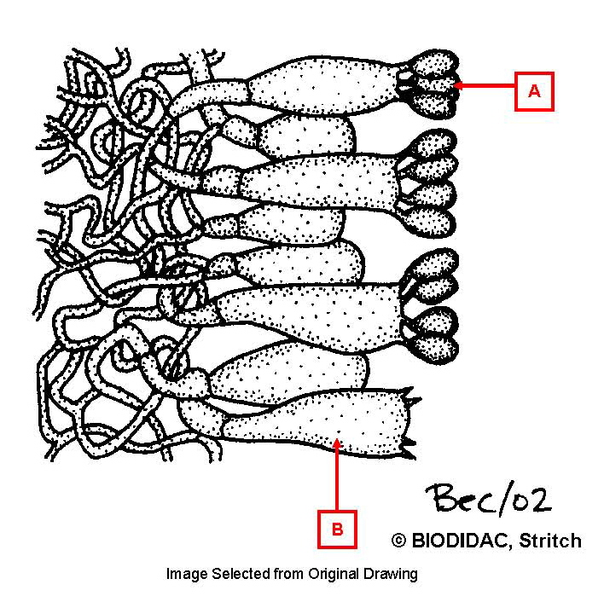

a. ascospore
*b. basidiospore
c. zygospore

16. On the closeup diagram of a mushroom gill, the structure labeled "b" is a/an

a. ascus
*b. basidium
c. sporangium
d. zygosporangium

17. On the closeup diagram of an ascocarp, the structure labeled "a" is a/an
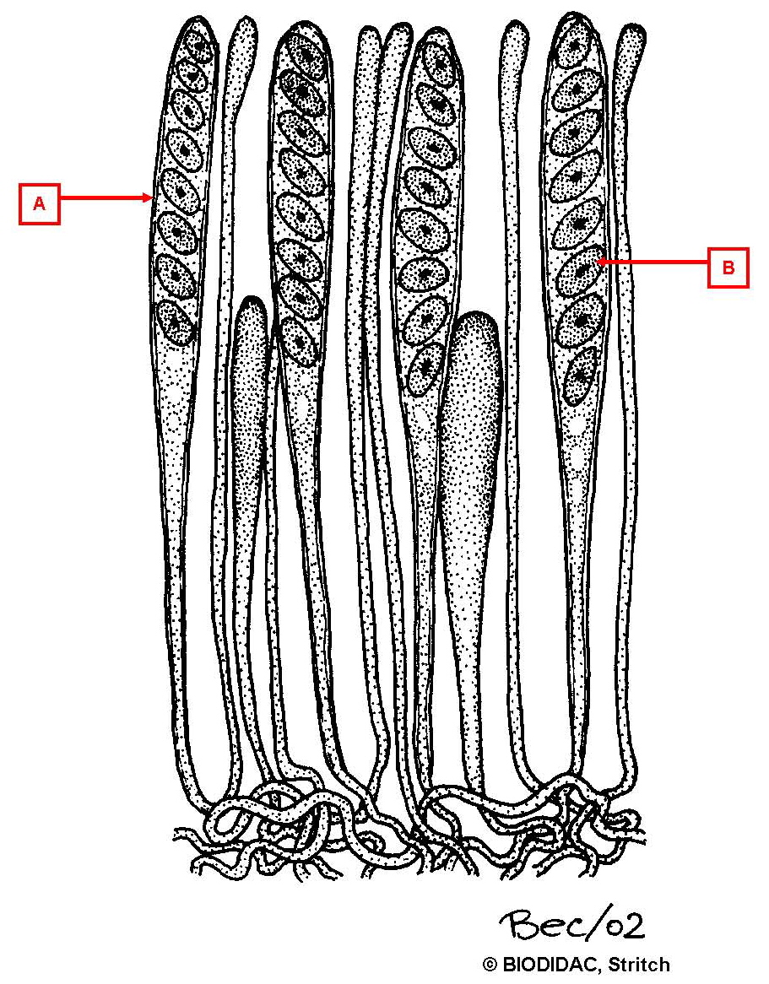

*a. ascus
b. basidium
c. sporangium
d. zygosporangium

18. On the closeup diagram of an ascocarp, the structure labeled "b" is a/an

*a. ascospore
b. basidiospore
c. zygospore

